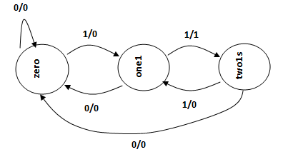

**Two consecutive 1s (11) sequence or pattern detector using Mealy FSM with three states. Here only non-overlapping patterns are detected.**

**module fsm_two1s_mealy2 (x, rst, clk, z);**

**input x, rst, clk;**

**output z; reg z;**

**parameter zero = 0, one1 = 1, two1s = 2;**

**reg [1:0] PS, NS;**

**always @ (posedge clk, rst)**

**if (rst)**

**PS <= zero;**

**else**

**PS <= NS;**

**always @ (PS or x)**

**case (PS)**

**zero: begin**

**z = x? 0:0;**

**NS = x? one1:zero;**

**end**

**one1: begin**

**z = x? 1:0;**

**NS = x? two1s:zero;**

**end**

**two1s: begin**

**z = x? 0:0;**

**NS = x? one1:zero;**

**end**

**default: begin**

**z = 0;**

**NS = zero;**

**end**

**endcase**

**endmodule**

**module tst_fsm_mealy;**

**reg x, rst, clk;**

**wire z;**

**fsm_two1s_mealy2 fsm2 (x, rst, clk, z);**

**initial begin**

**clk = 0;**

**x = 0;**

**#10 x = 1;**

**#20 x = 0;**

**#20 x = 1;**

**#20 x = 1;**

**#20 x = 1;**

**end**

**initial begin**

**rst = 1;**

**#10 rst = 0;**

**end**

**always**

**#10 clk = ~clk;**

**endmodule**

